Gulf Air (GF) New Baggage Policy | 24/09/2018

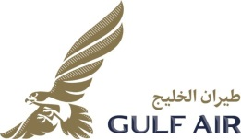
Effective the 28th of October 2018 Gulf Air is introducing new baggage policy.The piece concept will be applied and operative for tickets issued on/after 28 OCT 18 as shown in table below.

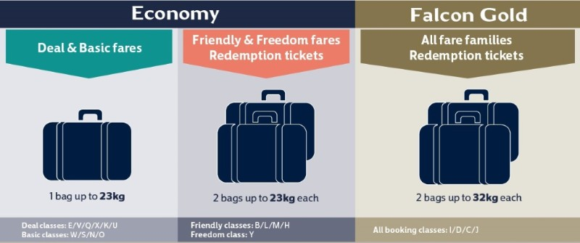

In addition, for Passengers originating Athens and traveling to:
Pakistan/India/Bangladesh/Sri Lanka/Philippines/Ethiopia & Sudan are allowed 2 pieces of checked baggage at 23kgs each on all Economy fares.
For tickets issued until the 27th of October, Gulf Air’s current weight system will apply. Hand baggage (carry-on) allowance remains unchanged (up to 6kgs).

